Exposure Java | Lab 12b
The <Deck> Class Program  "Dynamic Arrays Version" | 80, 90 & 100 Point Versions
Assignment Purpose:

This assignment is meant to demonstrate how to use a dynamic one-dimensional array in a class, including assigning values and displaying the array.

In this chapter the previously introduced Card class and the previously used Deck class will be used again. The provided Card class is not altered. The provided Deck class is similar to the starting Deck class of the Lab11b assignment. This time the program needs to be implemented with dynamic arrays using the ArrayList class. In a future chapter both the Card class and the Deck class will be used in the solitaire card game.

The Student Starting version, shown below, shows a minimal Deck class.

Lab12bst Student Version | Do not copy this file, which is provided.
// Lab12bvst.java This is the Student-Starting file.
// This version is implemented with "Dynamic Arrays"
// This assignment pertains to some of the "Elevens" AP Lab Materials
//***************************************************************************
// The "Elevens" AP Lab is created for the College Board APCS
// curriculum by Michael Clancy, Robert Glen Martin and Judith Hromcik.
// Leon Schram has altered some of the "Elevens" files to focus on
// specific CS topics as the "Elevens" Lab is integrated into the curriculum.
import java.util.ArrayList;
public class Lab12bst
{
public static void main(String[] args)
{
Deck deck = new Deck();
System.out.println(deck);
}
}

class Deck
{
private ArrayList<Card> cards;
private int size;
public Deck()
{
size = 52;
cards = new ArrayList<Card>();
}
}

80 Point Version Specifics

For the 80-point version you need to complete the constructor so that all 52 cards of a normal card deck are assigned to the cards array. Additionally, you need to re-define the toString method for the Deck class so that it can be used to display the attribute values in a convenient manner. Make sure to take advantage of the toString method that already exists in the Card class.

80 Point Version Output

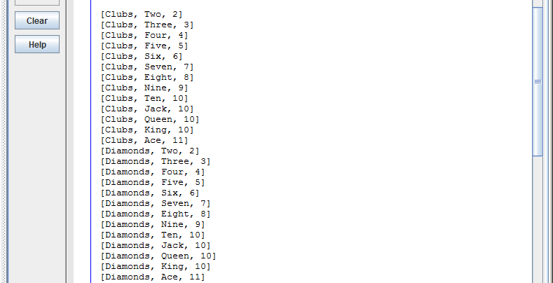

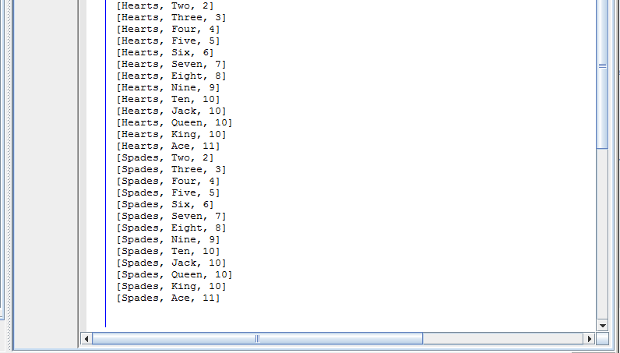

90 Point Version Specifics

For the 90-point version you need to add a shuffle method, which is called from the constructor. The shuffle method is a private helper method in the Deck class. For this version you need to shuffle the deck by swapping the cards. Generate two random numbers in the [0..51] number range that will represent the indexes of the cards array and swap the cards. Make 1000 swaps and then display the cards. The output display, shown below, will not necessarily be the same as your program. Use Math.random to generate random numbers.

90 Point Version Output

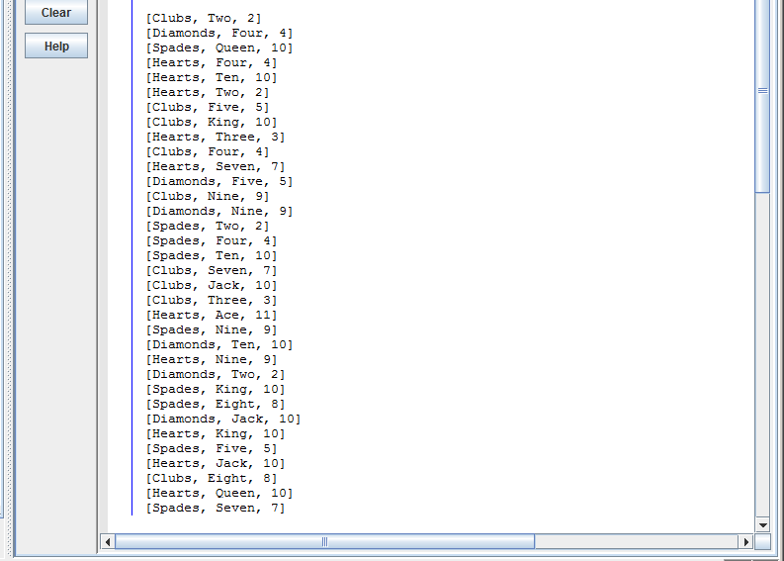

100 Point Version Specifics

The 100-point version adds a second shuffle method. Comment out the first shuffle method used for the 90-point version and then write a second shuffle method that places each card in a random location. Which of the two shuffle methods do you think is better for a card game? Do you think that perhaps are they are both equally effective?

100 Point Version Output

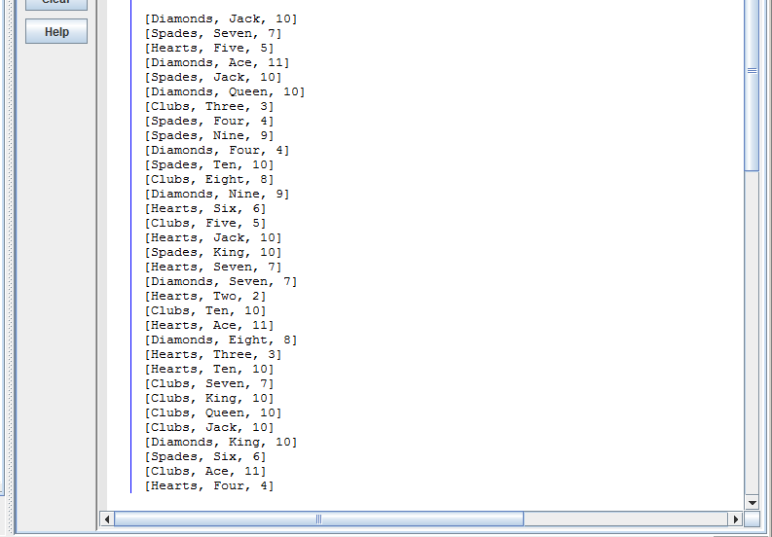

The logic of this lab assignment is similar to the logic of the Lab11b assignment. This gives you an opportunity to see how the same process can be implemented both with a static array and with a dynamic array.

Did you observe that the Lab11bst class and the Lab12bst class are identical, except for the class name? Looking at the code in the main method, which uses the Deck class, you cannot determine what type of data structure is used to implement the Deck class.

